8th Grade Science Homework Menu Week #16

Directions: You are to perform the following tasks on SEPARATE SHEETS OF PAPER and submit on Friday, February 13th. Each task is worth a specific amount of points. You NEED TO COMPLETE 20 POINTS worth of Homework to receive full credit.
1. Define the following terms: (5 Points)
a. inertia
b. momentum
c. claim
d. evidence
e. reasoning
f. Newton’s 1st Law of Motion
g. Newton’s 3rd Law of Motion

2. Momentum Problems (5 Points)
Complete these momentum practice problems on a separate sheet of paper:
1. A ping-pong ball has 2 kgm/s of momentum when thrown 8 m/s. Find the mass of the ball.
2. A 25 kg cart has 125 kgm/s of momentum. How fast is the cart going?
3. An object is going 22 m/s and is 3 kg. What is the object’s momentum?
4. A 75 kg speed skater is moving forward at 16 m/s. What is her momentum?
5.What is the momentum of a seated 8.5 kg passenger on a train that is stopped?

3. Inertia Problems (5 Points)
Of each of the pairs below, which has more inertia? How do you know?
1. Dog/Airplane 2. Marble/Bowling Ball 3. Feather/Textbook
4. Baseball, Golf ball 5. Car/Truck

4. Free Body Diagram Problems (5 Points)
1. Two boys push on a box. One pushes with a force of 125 N to the east. The other exerts a force of 165 N to the north. Draw and label the free body diagram with the correct forces and their value in Newtons. Then solve for the net force.

2. While flying due east with a force of 120 N, a hot air balloon is also carried west with a force of 45 N by the wind. Draw and label the free body diagram with the correct forces and their value in Newtons. Then solve for the net force.

3. Wind is blowing with a force of 45 N East toward the front of a plane whose engine is propelling it with a force of 155 N West. Draw and label the free body diagram with the correct forces and their value in Newtons. Then solve for the net force.

5. Claims, Evidence, Reasoning Practice (5 points)

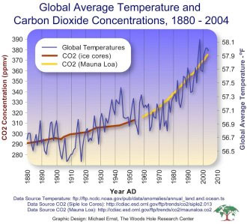
Using the graph above, what claims can be made about global average temperature and carbon dioxide concentrations over time? Use Evidence to support your claims.

Claim #1: Temperature and carbon dioxide have increased over the last 100 years.

Evidence to support the claim:

Claim #2:

Evidence to support the claim:

Claim #3:

Evidence to support the claim:

