7th Grade Science Homework Menu Week #6

Directions: You are to perform the following tasks on SEPARATE SHEETS OF PAPER and submit on Friday, October 31st. Each task is worth a specific amount of points. You NEED TO COMPLETE 20 POINTS worth of Homework to receive full credit.

1. Define the following terms: (5 Points)
a. DNA
b. nucleotide
c. DNA replication
d. Protein synthesis
e. RNA
f. mutation
g. insertion
h. deletion
i. substitution

2. Create a mnemonic device that will help you remember the four bases of DNA and how they can pair. Example: Atoms are Tiny (Adenine and Thymine) or Cathy is Great (Cytosine and Guanine) (5 Points)

3. Answer the following questions: (5 Points)
a. What does DNA stand for?
b. What two scientists established the structure of DNA?
c. DNA is sometimes described as a twisted ladder. What is the name of this shape?

4. a. Create a matching (complementary) DNA sequence for the following strand
b. Create a matching DNA sequence in which a deletion mutation happened
c. Create a matching DNA sequence in which an substitution mutation happened. (5 Points)

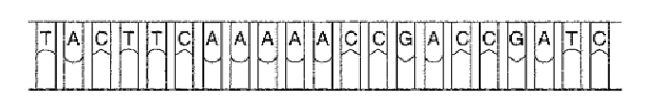

5. Create a short comic, illustrating the three steps of DNA replication (5 Points)

